Database System Engineering and Distributed Backend Development
BANK DATABASE — SQL VIEWS

Name: Pudota Asritha Chowdary
Roll No: 2520030592
Section: 7

QUERY 1 — Create Database
CREATE DATABASE BankDB;
USE BankDB;

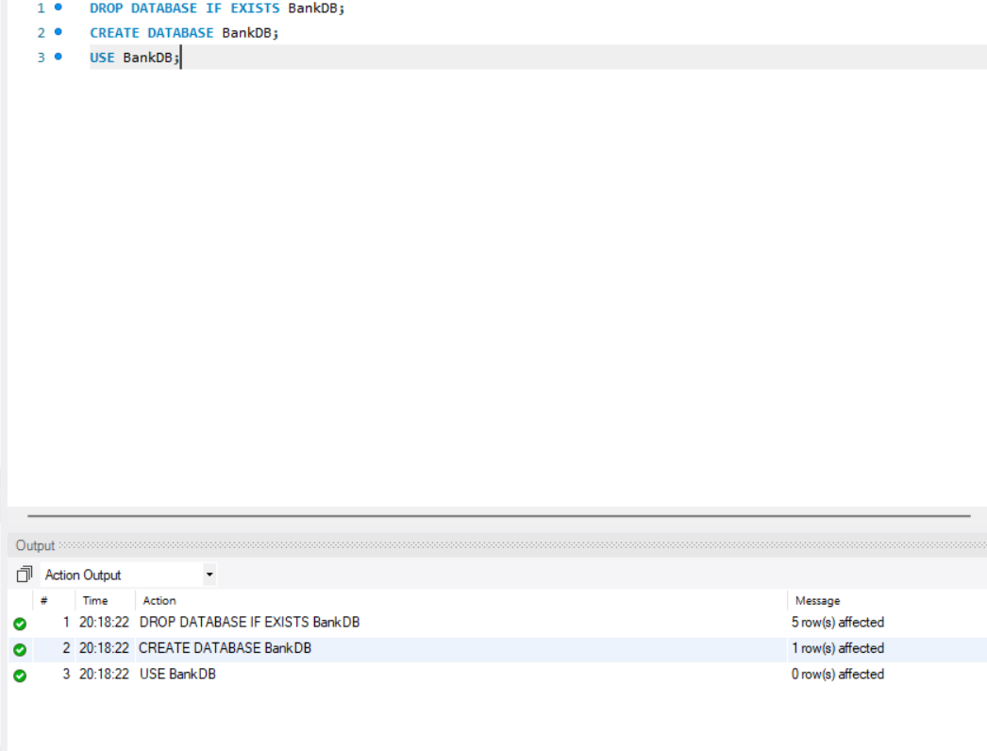

QUERY 2 — Create Customer Table

CREATE TABLE Customer (
Customer_ID INT PRIMARY KEY,
Customer_Name VARCHAR(100) NOT NULL,
Phone VARCHAR(15),
Email VARCHAR(100),
City VARCHAR(50)
);

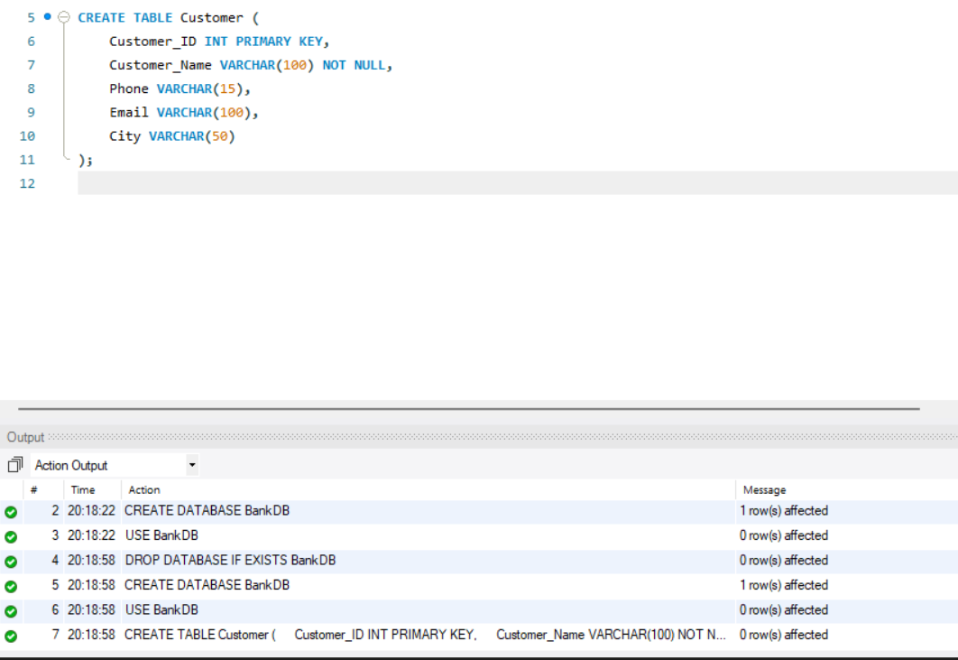

QUERY 3 — Create Account Table
CREATE TABLE Account (
Account_No INT PRIMARY KEY,
Customer_ID INT,
Account_Type VARCHAR(20),
Balance DECIMAL(12,2),
Branch VARCHAR(50),
FOREIGN KEY (Customer_ID) REFERENCES Customer(Customer_ID) );

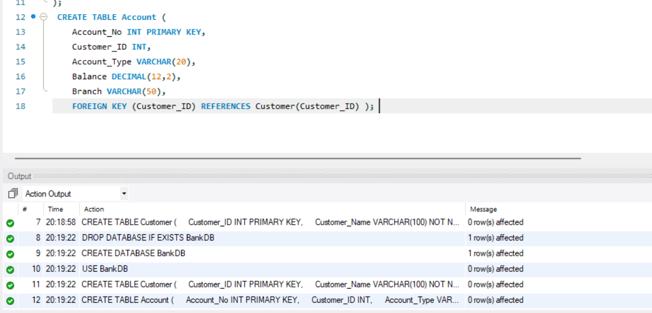

QUERY 4 — Create Bank_Transaction Table
CREATE TABLE Bank_Transaction (
Transaction_ID INT PRIMARY KEY AUTO_INCREMENT,
Account_No INT,
Transaction_Type VARCHAR(20),
Amount DECIMAL(12,2),
Transaction_Date DATETIME DEFAULT CURRENT_TIMESTAMP,
FOREIGN KEY (Account_No) REFERENCES Account(Account_No) );

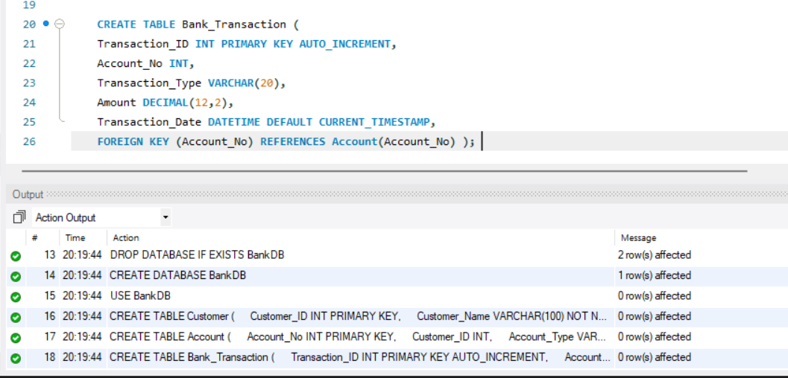

QUERY 5 — Create Loan Table
CREATE TABLE Loan (
Loan_ID INT PRIMARY KEY,
Customer_ID INT,
Loan_Type VARCHAR(30),
Loan_Amount DECIMAL(12,2),
Interest_Rate DECIMAL(5,2),
FOREIGN KEY (Customer_ID) REFERENCES Customer(Customer_ID) );

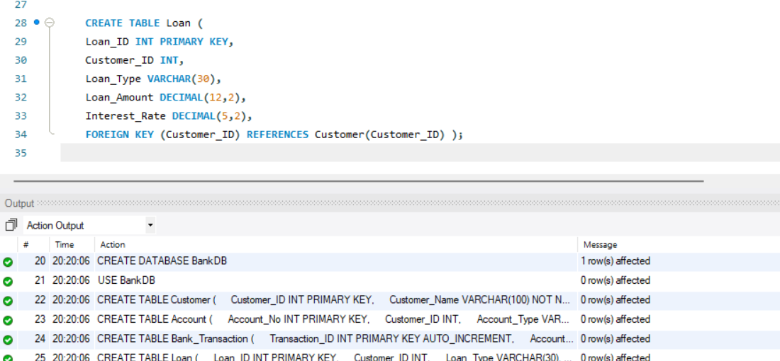

6 — Insert Customer Records + Display
INSERT INTO Customer (Customer_ID, Customer_Name, Phone, Email, City) VALUES
(101, 'Asritha Chowdary', '9876543210', 'pasrithachowdary@klh.edu.in', 'Hyderabad'),
(102, 'Priya Sharma', '9876543211', 'priya.sharma@gmail.com', 'Vijayawada'),
(103, 'Arjun Reddy', '9876543212', 'arjun.reddy@gmail.com', 'Bangalore'), (104, 'Sneha Rao', '9876543213', 'sneha.rao@gmail.com', 'Chennai'),
(105, 'Kiran Kumar', '9876543214', 'kiran.kumar@gmail.com', 'Hyderabad'),
(106, 'Anil Verma', '9876543215', 'anil.verma@gmail.com', 'Delhi'),
(107, 'Meena Iyer', '9876543216', 'meena.iyer@gmail.com', 'Mumbai'),
(108, 'Rahul Nair', '9876543217', 'rahul.nair@gmail.com', 'Pune'),
(109, 'Lakshmi Devi', '9876543218', 'lakshmi.devi@gmail.com', 'Hyderabad'),
(110, 'Suresh Babu', '9876543219', 'suresh.babu@gmail.com', 'Vijayawada');

SELECT * FROM Customer;

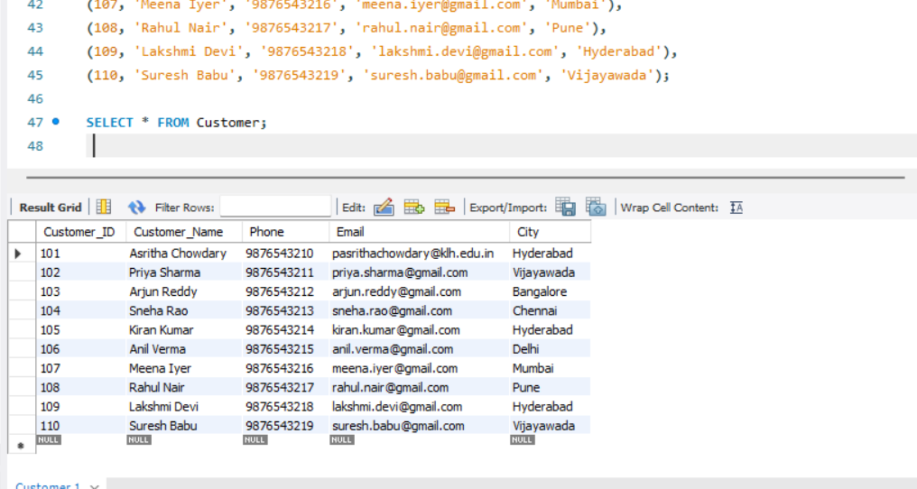

QUERY 7 — Insert Account Records + Display
INSERT INTO Account (Account_No, Customer_ID, Account_Type, Balance, Branch) VALUES
(10001, 101, 'Savings', 50000, 'Hyderabad'),
(10002, 102, 'Savings', 75000, 'Vijayawada'),
(10003, 103, 'Current', 120000, 'Bangalore'),
(10004, 104, 'Savings', 45000, 'Chennai'),
(10005, 105, 'Current', 90000, 'Hyderabad'),
(10006, 106, 'Savings', 65000, 'Delhi'),
(10007, 107, 'Current', 150000, 'Mumbai'),
(10008, 108, 'Savings', 35000, 'Pune'),
(10009, 109, 'Savings', 85000, 'Hyderabad'),
(10010, 110, 'Current', 110000, 'Vijayawada');

SELECT * FROM Account;

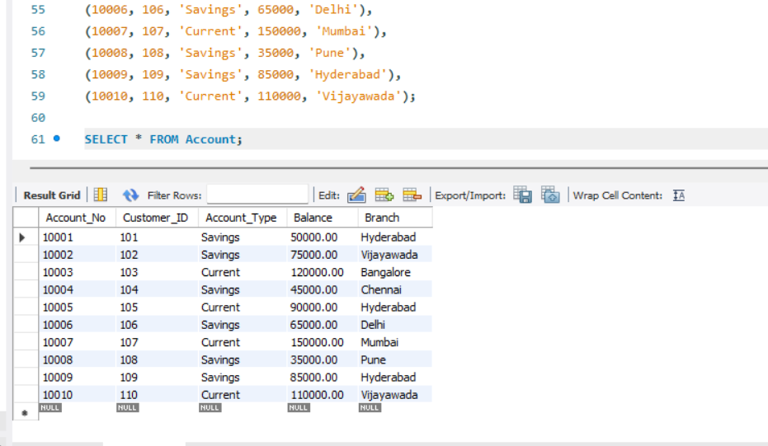

QUERY 8 — Insert Bank_Transaction Records + Display
INSERT INTO Bank_Transaction (Account_No, Transaction_Type, Amount) VALUES
(10001, 'DEPOSIT', 10000),
(10001, 'WITHDRAW', 5000),
(10002, 'DEPOSIT', 15000),
(10003, 'WITHDRAW', 20000), (10004, 'DEPOSIT', 5000),
(10005, 'WITHDRAW', 10000),
(10006, 'DEPOSIT', 12000),
(10007, 'DEPOSIT', 25000),
(10008, 'WITHDRAW', 5000),
(10009, 'DEPOSIT', 20000),
(10010, 'WITHDRAW', 15000);

SELECT * FROM Bank_Transaction;

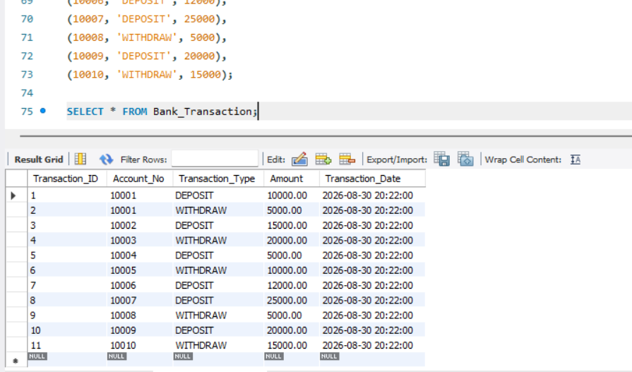

9 — Insert Loan Records + Display
INSERT INTO Loan (Loan_ID, Customer_ID, Loan_Type, Loan_Amount, Interest_Rate) VALUES
(501, 101, 'Home Loan', 5000000, 7.5),
(502, 102, 'Education Loan', 1000000, 6.5),
(503, 103, 'Car Loan', 800000, 8.2),
(504, 104, 'Personal Loan', 500000, 10.5),
(505, 105, 'Home Loan', 4000000, 7.2),
(506, 106, 'Car Loan', 900000, 8.5),
(507, 107, 'Business Loan', 3000000, 9.0),
(508, 109, 'Personal Loan', 600000, 10.0);

SELECT * FROM Loan;

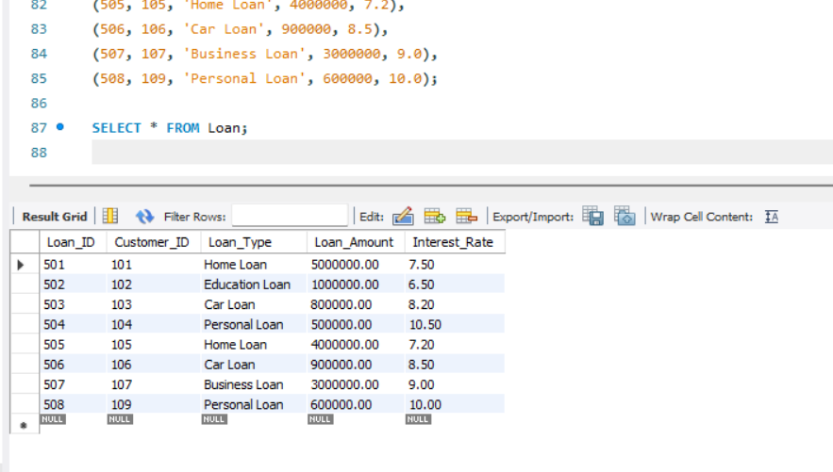

QUERY 10 — Simple View (View of an Entire Table)
CREATE VIEW Customer_View AS
SELECT * FROM Customer;

SELECT * FROM Customer_View;

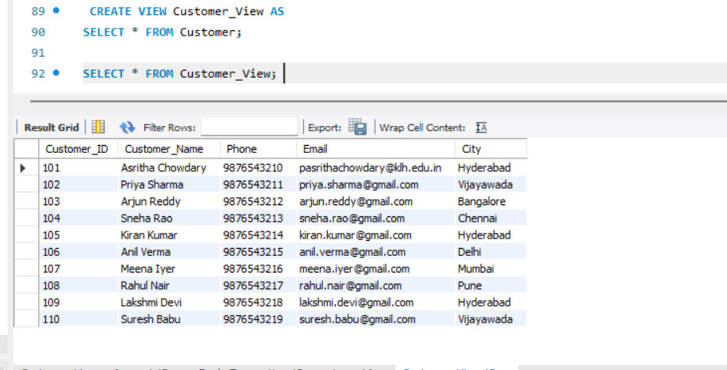

11 View Using WHERE (Filtered View)
CREATE VIEW Savings_Account_View AS
SELECT * FROM Account
WHERE Account_Type = 'Savings';

SELECT * FROM Savings_Account_View;

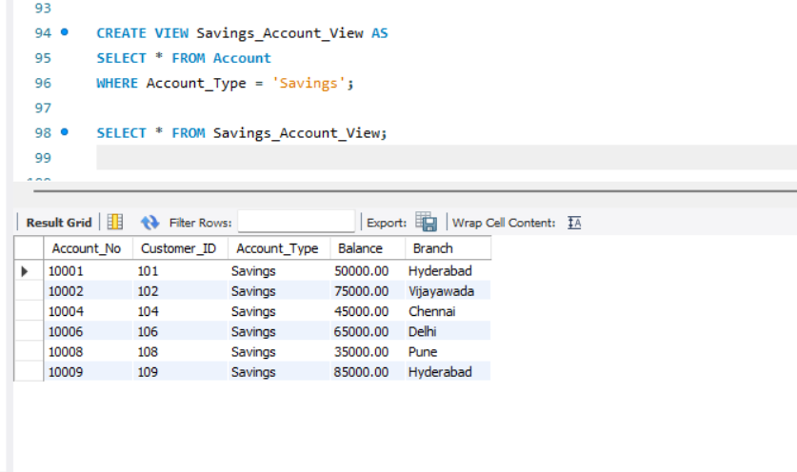

QUERY 12 — View Using JOIN (Combining Two Tables)
CREATE VIEW Customer_Account_View AS
SELECT
C.Customer_ID,
C.Customer_Name,
C.City,
A.Account_No,
A.Account_Type,
A.Balance,
A.Branch
FROM Customer C
JOIN Account A ON C.Customer_ID = A.Customer_ID;

SELECT * FROM Customer_Account_View;
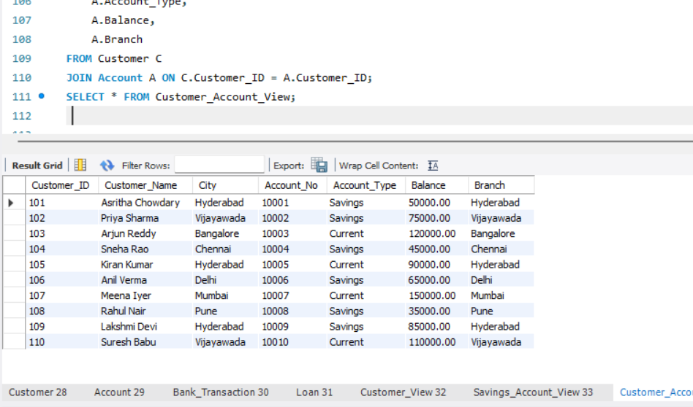

13 View Using GROUP BY + Aggregate Function
CREATE VIEW Branch_Total_Balance AS
SELECT
Branch,
SUM(Balance) AS Total_Balance
FROM Account
GROUP BY Branch;

SELECT * FROM Branch_Total_Balance;

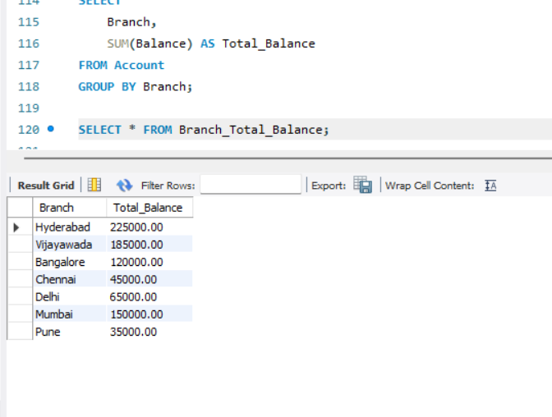

QUERY 14 — View Using HAVING (Filter After Grouping)
CREATE VIEW Rich_Branches AS
SELECT
Branch,
SUM(Balance) AS Total_Balance
FROM Account
GROUP BY Branch
HAVING SUM(Balance) > 100000;

SELECT * FROM Rich_Branches;
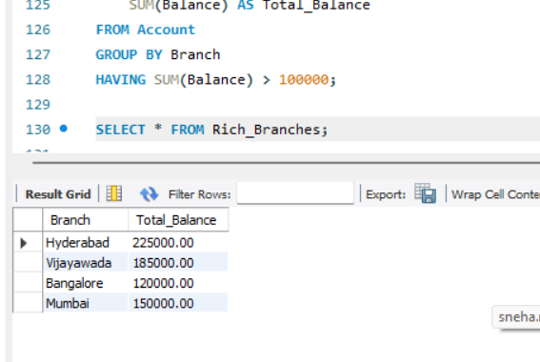

15 Update Through a View + Drop a View
CREATE VIEW Account_View AS
SELECT Account_No, Customer_ID, Account_Type, Balance, Branch
FROM Account;

UPDATE Account_View
SET Balance = 60000
WHERE Account_No = 10001;

SELECT * FROM Account WHERE Account_No = 10001;

DROP VIEW Account_View;

